**Practical task**

1. Create a Node . js http server that will listen for requests on port 5000 on the local machine. The server should return a page containing the name of the current user of the operating system, the type of the operating system, the system's operating time in minutes (use the [OS module](https://nodejs.org/api/os.html) ), the current working directory and the name of the server file (use the [path module](https://nodejs.org/dist/latest-v10.x/docs/api/path.html) ).

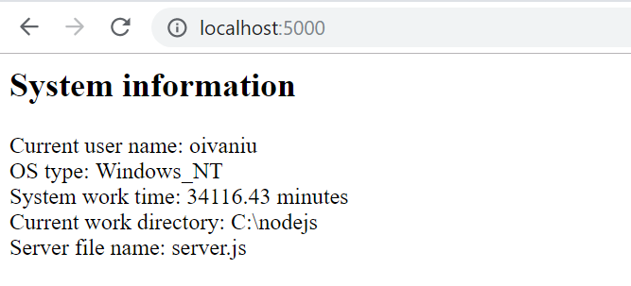

2. It is necessary to create your own module *personalmodule. js* , which contains a function that accepts the name of the system user and works with the current time and, based on the time of day, displays a message greeting the user. To export module variables or functions externally, you can use the *module.exports object* .

Create Node . js server, which, using the functionality of the developed module, will return the following page :

